**Specify The Business Problem**

Technological advancement in transportation has minimised the distances but has increased the risk to life. Every year, accidents result in loss of lakhs of lives and serious injuries to crores of people. A study to analyse road safety and accident trends in India is to be conducted using Qlik Sense, a data analytics platform. This study involves examining data related to road incidents, such as types of accidents, locations, causes, and potentially factors contributing to road safety or risks. The use of Qlik Sense is a data-driven approach, utilizing visualizations and insights generated from the analysis to understand patterns and potentially inform strategies for improving road safety in India.

### Business Requirements

The analysis aims to provide valuable insights into user demographics, accident patterns, and problem areas. The primary focus is on creating interactive and visually compelling dashboards to support strategic planning and operational improvements. The insights derived from this analysis will be instrumental in making informed decisions, implementing better safety protocols, and ensuring compliance with regulations.

### Literature Survey

A literature survey for the Road Safety and Accident Patterns analysis would involve researching and reviewing previous studies, articles, reports and figures on the topic. This could include information on the methods and techniques used for analysing accidents data, as well as the results and conclusions of these studies. It is recommended to explore academic databases such as PubMed, IEEE Xplore, Google Scholar, and institutional repositories. Additionally, government reports and publications can provide insights into the latest developments.

Analyzing road safety and accident patterns in India using Qlik can provide valuable insights into various factors contributing to accidents, such as road conditions, driver behavior, vehicle types, weather conditions, and more. Here's a step-by-step approach to conducting such an analysis:

1. **Data Collection**: Gather relevant data from sources such as government reports, police records, traffic management authorities, and any other reliable sources. This data should include information about accidents, such as location, time, date, severity, types of vehicles involved, road conditions, weather conditions, etc.
2. **Data Cleaning and Preparation**: Before importing the data into Qlik, clean and prepare it. This involves removing duplicates, handling missing values, and standardizing formats to ensure consistency.
3. **Import Data into Qlik**: Import the cleaned data into Qlik Sense or QlikView. These tools allow you to easily visualize and analyze data through intuitive dashboards and charts.
4. **Create Dashboards**: Design dashboards in Qlik that display key metrics and insights related to road safety and accident patterns. Consider creating different sheets or tabs for various aspects of the analysis, such as:
   * Overview Dashboard: Provide a high-level summary of accident trends over time, geographic distribution of accidents, and severity.
   * Geographic Analysis: Use maps to visualize accident hotspots, traffic congestion areas, and areas with poor road conditions.
   * Time Analysis: Analyze accidents based on time of day, day of the week, month, and year to identify patterns and trends.
   * Vehicle Analysis: Explore the types of vehicles involved in accidents, such as cars, trucks, motorcycles, etc., and their contribution to accidents.
   * Contributing Factors: Investigate factors such as weather conditions, road conditions, driver behavior (speeding, drunk driving, distracted driving), and their impact on accident rates.
   * Casualty Analysis: Examine the severity of accidents, including fatalities, injuries, and property damage.
5. **Interactive Visualizations**: Utilize Qlik's interactive features to allow users to drill down into data and explore specific aspects of road safety and accident patterns. For example, users should be able to filter data based on location, time period, severity, and other relevant criteria.
6. **Identify Insights and Trends**: Analyze the visualizations and metrics to identify insights and trends. Look for correlations between different variables and factors that contribute to accidents. For instance, you may discover that accidents tend to increase during certain weather conditions or at specific times of the day.
7. **Data Storytelling**: Use the insights gained from the analysis to tell a compelling data story. Clearly communicate the key findings, trends, and recommendations for improving road safety in India.
8. **Iterate and Refine**: Continuously iterate on your analysis based on feedback and new data. Refine your dashboards and visualizations to make them more informative and user-friendly.

By following these steps, you can leverage Qlik to conduct a comprehensive analysis of road safety and accident patterns in India, ultimately leading to informed decision-making and interventions to improve road safety.

### Social Impact

### Social Impact Analysis:

• Create visualizations to display the demographic distribution of accidents across the country.

• Compare the severity of accidents in different areas of traffic control.

• Explore any correlation between speeding, weather, and total accidents.

• Identify the leading causes of accidents.

• Examine the distribution of age groups and gender of the victims.

• Investigate the contribution of diverse types of vehicles to the total number of accidents.

### Prepare The Data For Visualization

Preparing the data for visualization involves cleaning the data to remove irrelevant or

missing data, transforming the data into a format that can be easily visualized, exploring the data to identify patterns and trends, filtering the data to focus on specific subsets of data, preparing the data for visualization software, and ensuring that the data is accurate and complete. This process helps to make data easily understandable and ready for creating visualizations to gain insights.

### Number Of Unique Visualizations

The number of unique visualizations that can be created with a given dataset. Some common types of visualizations that can be used to analyse include bar charts, line charts, heat maps, scatter plots, pie charts, maps etc. These visualizations can be used to compare, track changes over time, show distribution, relationships between variables, breakdown of one category and much more.

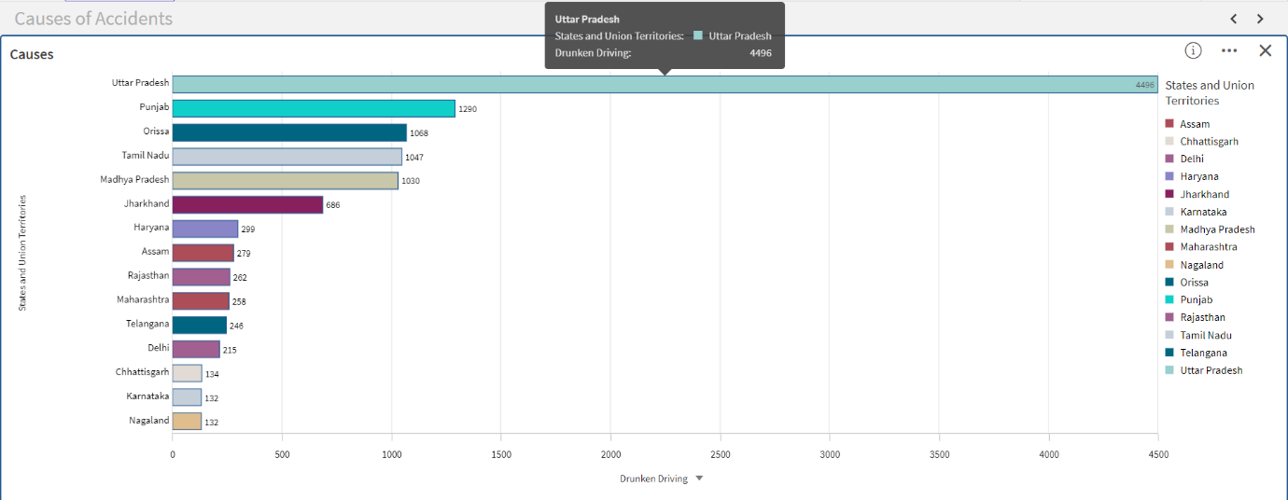

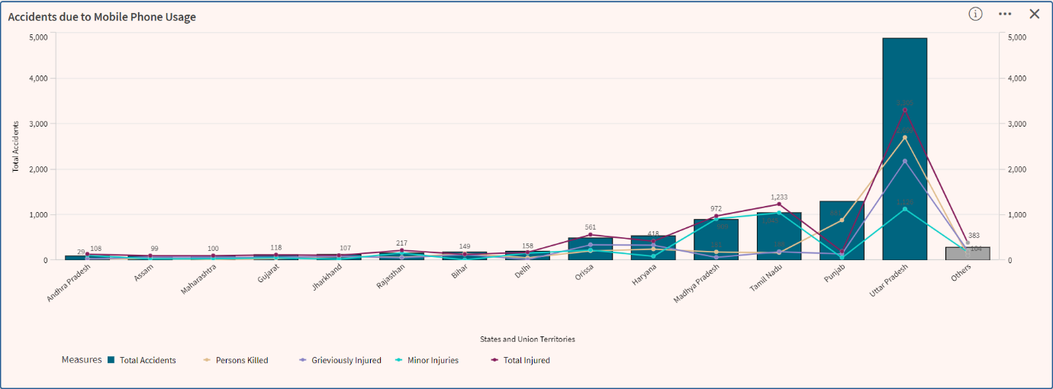

Activity 1.4: Vehicle Contribution towards Total Accidents

Activity 1.5: Accidents by Weather Type

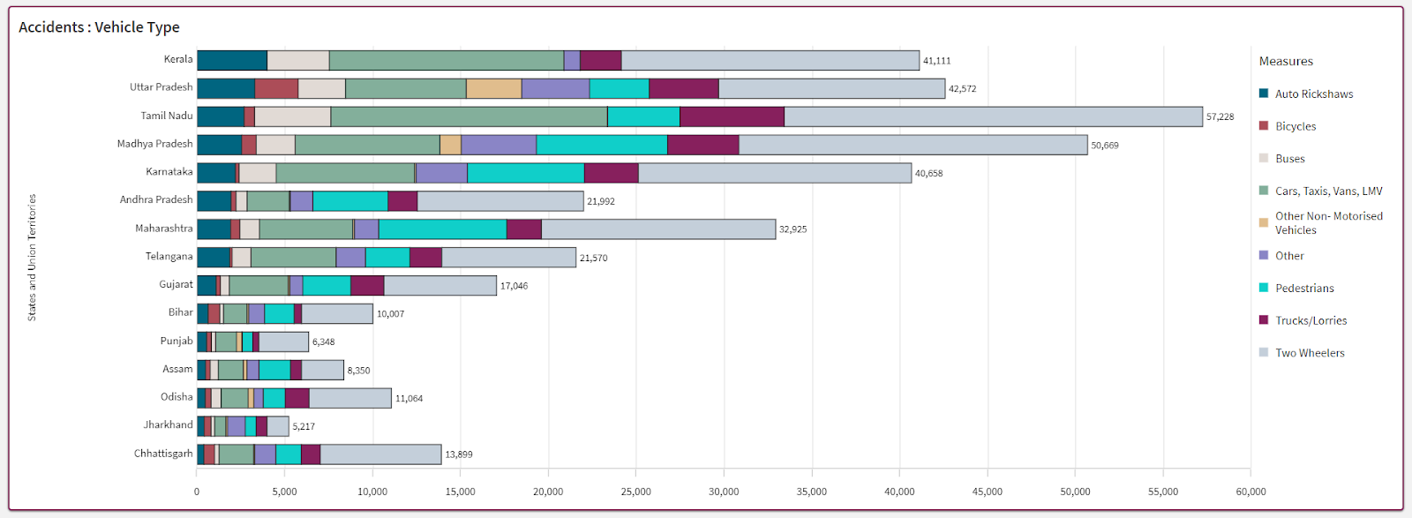

### Storytelling

A data story is a way of presenting data and analysis in a narrative format, with the goal of making information more engaging and easier to understand. A data story typically includes a clear introduction that sets the stage and explains the context for the data, a body that presents the data and analysis in a logical and systematic way and a conclusion that summarizes the key findings and highlights their implications. Data stories can be told using a variety of media, such as reports, presentations, interactive visualizations and videos.

### Application Of Data Filters

Selections within the data allows users to filter data based on individual fields or dimensions. Users can choose specific values within a field to include or exclude from analysis. Complex filters based on predefined conditions and logic can also be created.

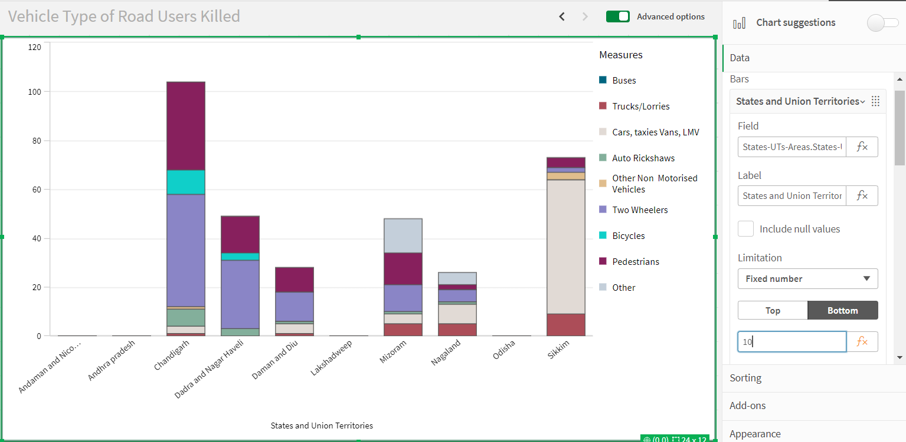

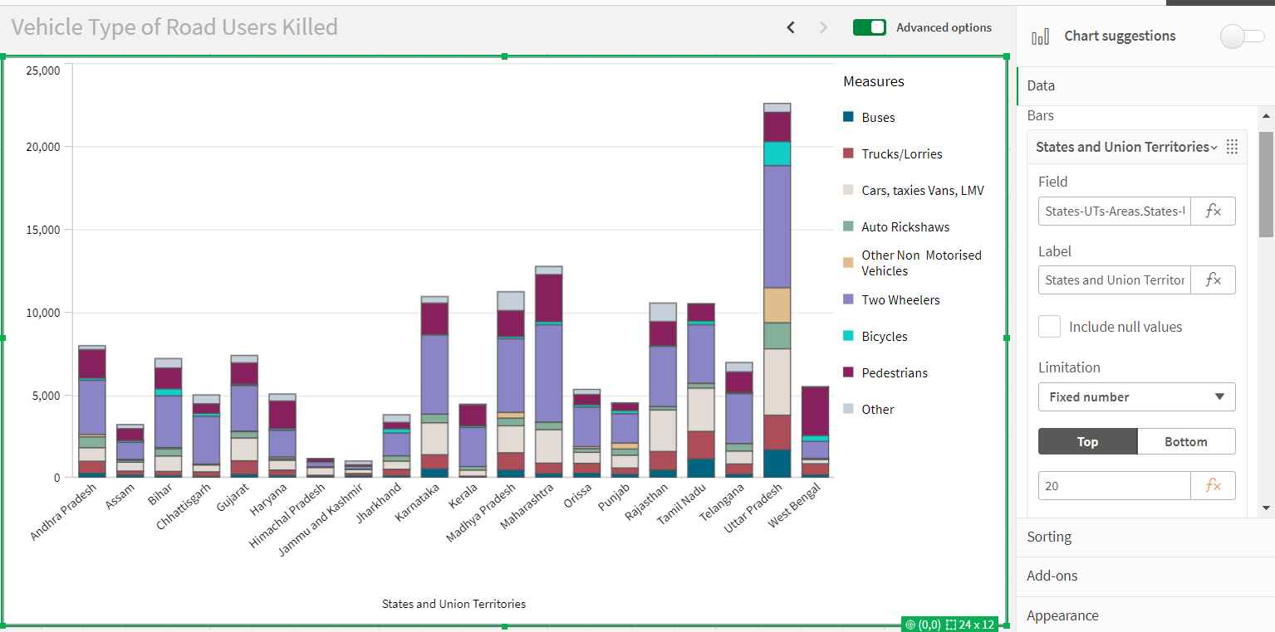

**Number Of Graphs/ Visualizations**

1. Accidents due to Drunken Driving
2. State-wise Mobile Phone Usage
3. Vehicle Contribution towards Total Accidents
4. Correlation - Speeding and Number of accidents
5. Accidents by Weather Type
6. Minors Injured across the country
7. Pedestrians Killed: Gender
8. Pedestrians Killed: Age groups
9. Road Users Killed: Vehicle Distribution

### Project Demonstration & Documentation

Below mentioned deliverables to be submitted along with other deliverables.

Activity 1: Record explanation video for the project's end-to-end solution

Activity 2: Project Documentation-step by step project development procedure

Create the document as per the template provided.